Hello generous business owner,
FITS Academy is a local wrestling program that serves the youth in our community by providing year-round training opportunities. We’re looking for motivated business owners to stand behind our vision of helping students learn valuable life lessons through the challenges that an individual sport like wrestling offers.
By becoming a sponsor, you will be helping bring in NCAA All-Americans and high-level coaches to our camps this Summer. These camps will be a great opportunity for our wrestlers to learn cutting-edge technique from some of the best in the country and be inspired by the stories of these high-level athletes/coaches about their wrestling journey.
In the spirit of competition, we are offering the following sponsorship levels
- Gold Sponsor- $1000 (Business logo on t-shirts, company advertised in emails to 600+ local families, and website listed on our sponsor page)
- Silver Sponsor- $500 (Company advertised in emails to 600+ local families, and your website will be listed on our sponsor page)
- Bronze Sponsor- $250 (Company website listed on our sponsor page)
Sponsorship donations can be made
- Through the Venmo App (@FITSWrestling)
-Online (via Paypal) http://www.fitswrestlingacademy.com/sponsors
Checks are also welcome; payable to FITS Wrestling Academy. Just give the check to the wrestler/parent/coach to turn in at practice.
Thank you for your support in helping us grow wrestling and making our Summer Camps special!
Sincerely,
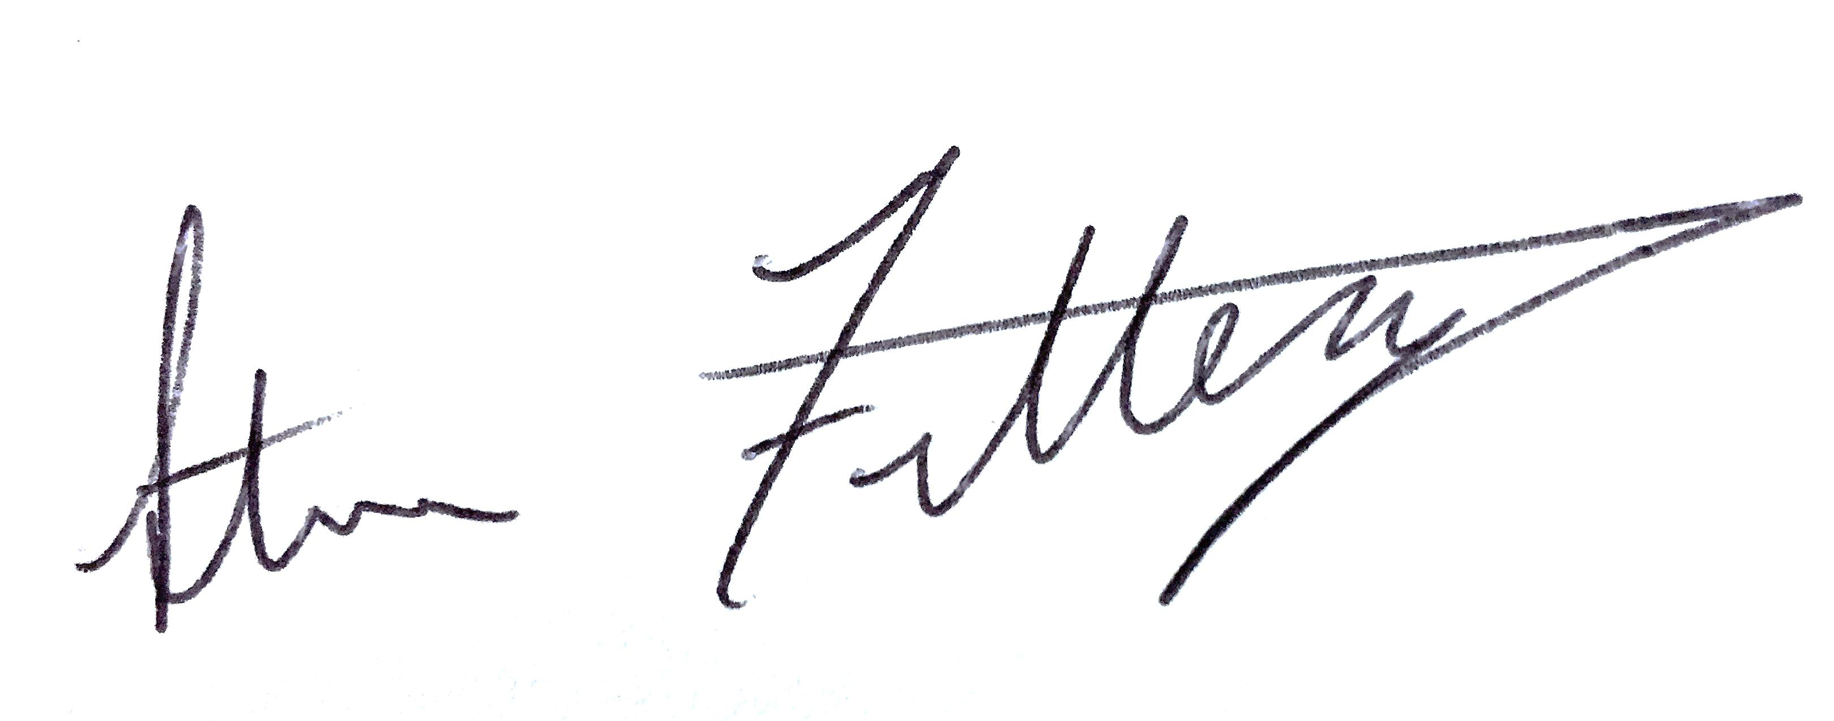
-Steve Fittery; FITS Academy Director

